6th Annual ECU Spring
Wrestling Clinic
Sunday, March 19, 2017

“We loved the camp & every wrestler got a lot from this awesome ECU camp!!” – Coach Tony White – Warwick H.S., Newport News -
kk

Milt Sherman
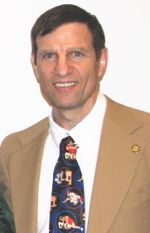
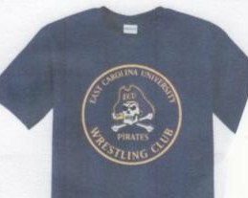

Tom Marsh
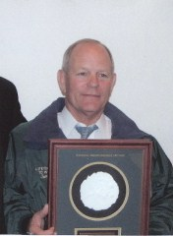

Bob Guzzo
8:30 AM – Registration
9:00 Milt Sherman – Takedown Defense, Arm Drags
- ECU Athletics Hall of Fame
- All-American
- Nat. Wrestling Hall of Fame – NC Chapter
10:00 Ron Williams – Leg Wrestling
- Nat. Wrestling Hall of Fame – NC Chapter
- ECU Varsity Letterman, Athens Drive Head Coach
11:00 Binky Moore – Cradles
- ECU Coach
- H.S. All-American, 2-time State Champ
12:00 PM – Lunch (Arby’s, Sheetz, McDonald’s, Subway, and more within 2 blocks) + SRC snack bar & tables
1:00 Phil Mueller – Arm Bars
- 3-Time All-American
- Southern Conf. Outstanding Wrestler For ECU
- Nat. Wrestling Hall of Fame – NC Chapter
2:00 Tom Marsh – Front Headlock & Radman Series
- ECU Varsity Letterman
- Nat. Wrestling Hall of Fame – NC Chapter
- With ECU Coach Jamie Yezarski (Wrestling Warehouse)
3:00 Tim McAteer – Roll Series – 5 pt moves
- 4-year ECU Varsity Letterman
- Virginia h.s. head coach & referee

Great Teacher/Student Ratio
Coaches are Assisted by the ECU Wrestling Team
Coaches attend free
Feel free to video tape
Clinic will be held at the East Carolina University Student Recreation Center
(Located at 7th and Cotanche Streets)
Park @ 9th & Cotanche Streets
$40, or $35 in advance (Includes Team T-shirt)
6 Hours of Instruction!
Please make checks payable to:
“ECU Wrestling”
Mail To:
128 Student Rec
East Carolina University
Greenville, NC 27858
For Questions & RSVP please contact us at:
shermanm@ecu.edu

Name: ___________________________________________________
Address: _________________________________________________
City: ___________________________ State: ________ Zip: ________
School: __________________________________________________
Email: __________________________________
Shirt Size: XS S M L XL 2XL (adult sizes)
**Additional Shirts are $12 each on day of clinic if extras are available. **
“You get Hall of Fame coaching at ECU”

